Biological Indicator Incubator——Bit1000/Bit1000-S
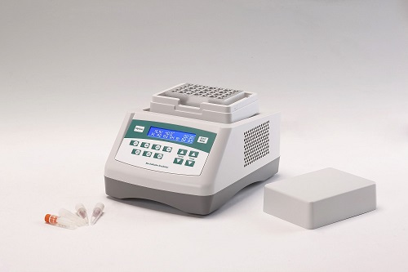
Description:
Bit1000/Bit1000-S is a sample incubation equipment based on film heating and PID automatic temperature control technology. Flexible independent timing and constant temperature function improve the efficiency of the laboratory work, which is the ideal equipment for biological indicators incubation.
Features:
- Easy to set up and use, all information real-time display and showing set
up operation, convenient to observe equipment running status.
- High temperature control precision.
- Wide time range from 1min to 99h59min.
- Up to 7groups samples can be incubated. Each group countdowns independently at a time.
- Automatic running function.
- Temperature calibration function.
- Built-in software and hardware over-temperature protection device, will use more reliable.

Parameters:
Project | Parameters
Temp setting range | 0℃~100℃
Temp control range | RT+5℃~100℃
Time range | 1min ~ 99h59min/∞
Temp accuracy | ≤±0.3℃*
Display accuracy | 0.1℃
Temp uniformity | ≤±0.3℃*
Heating time | ≤12min(from 25℃ to 100℃)*
Automatic running | Yes
Capacity | See optional block
Power | 150W
Voltage | AC220V/50-60HZ
Fuse | 250V 3A Ф5×20
Dimension(mm) | 260x195x150mm
Weight(kg) | 2.5

Optional block
Type | Capacity | Remark
RC02 044 001 | 35xΦ9mm | Only for Bit1000
RC02 044 002 | 35xΦ10mm | Only for Bit1000
RC02 044 003 | 28xΦ12mm | Only for Bit1000-S
*If you have special requirements on block, please contact to supplier to customize blocks.

